接金币

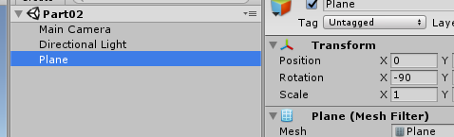

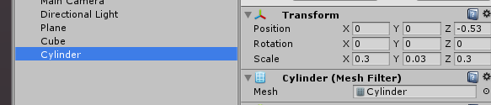

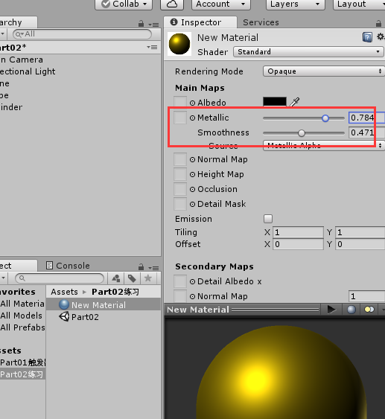

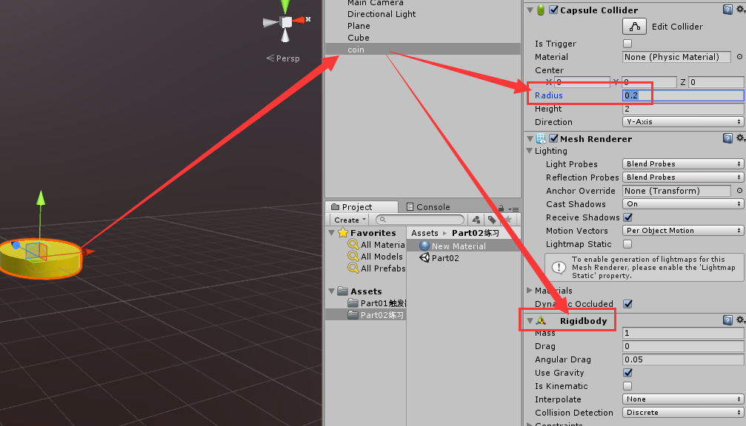

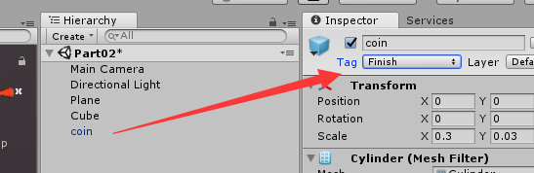

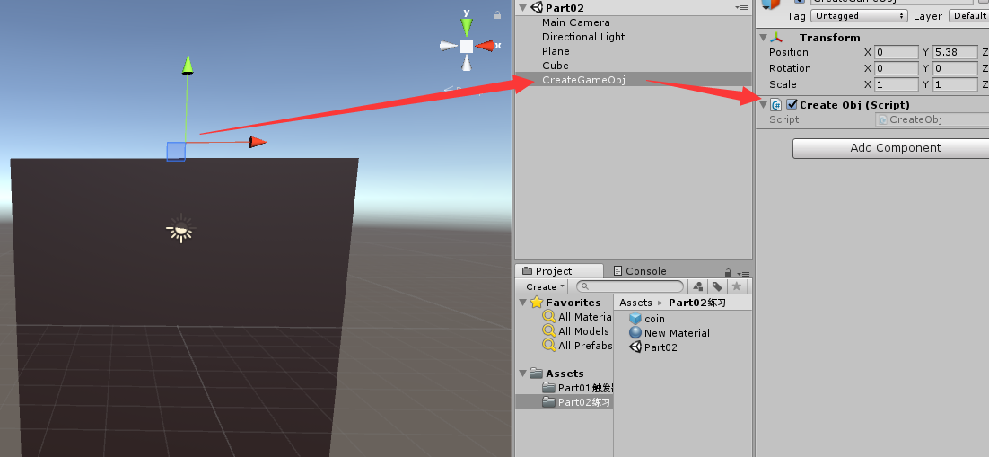

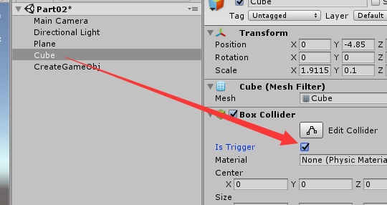

**代码：**

public class Part2cubemove : MonoBehaviour

{

public float speed = 4f;

void Start()

{

}

void Update()

{

float hor = Input.GetAxis("Horizontal");

if (hor != 0)

{

transform.position += transform.right * hor * Time.deltaTime * speed;

//限制移动

transform.position = new Vector3(Mathf.Clamp(transform.position.x, -4.5f, 4.5f), transform.position.y, transform.position.z);

}

if((Input.GetKey(KeyCode.A)&&Input.GetKey(KeyCode.LeftShift))||(Input.GetKey(KeyCode.D) && Input.GetKey(KeyCode.LeftShift)))

{

speed = 10f;

}

else

{

speed = 4f;

}

}

private void OnTriggerEnter(Collider other)

{

if (other.gameObject.tag == "Finish")

{

Destroy(other.gameObject);

}

}

}

public class CreateCion : MonoBehaviour

{

GameObject coin;

void Start()

{

coin = Resources.Load<GameObject>("cion");

InvokeRepeating("CreateCoin", 2, 2);

}

void CreateCoin()

{

GameObject obj = Instantiate(coin, new Vector3(Random.Range(-4.5f,4.5f),transform.position.y,transform.position.z), Quaternion.identity);

//旋转

obj.GetComponent<Rigidbody>().angularVelocity = new Vector3(45, 45, 45);

}

}